Studio Time: June 2014

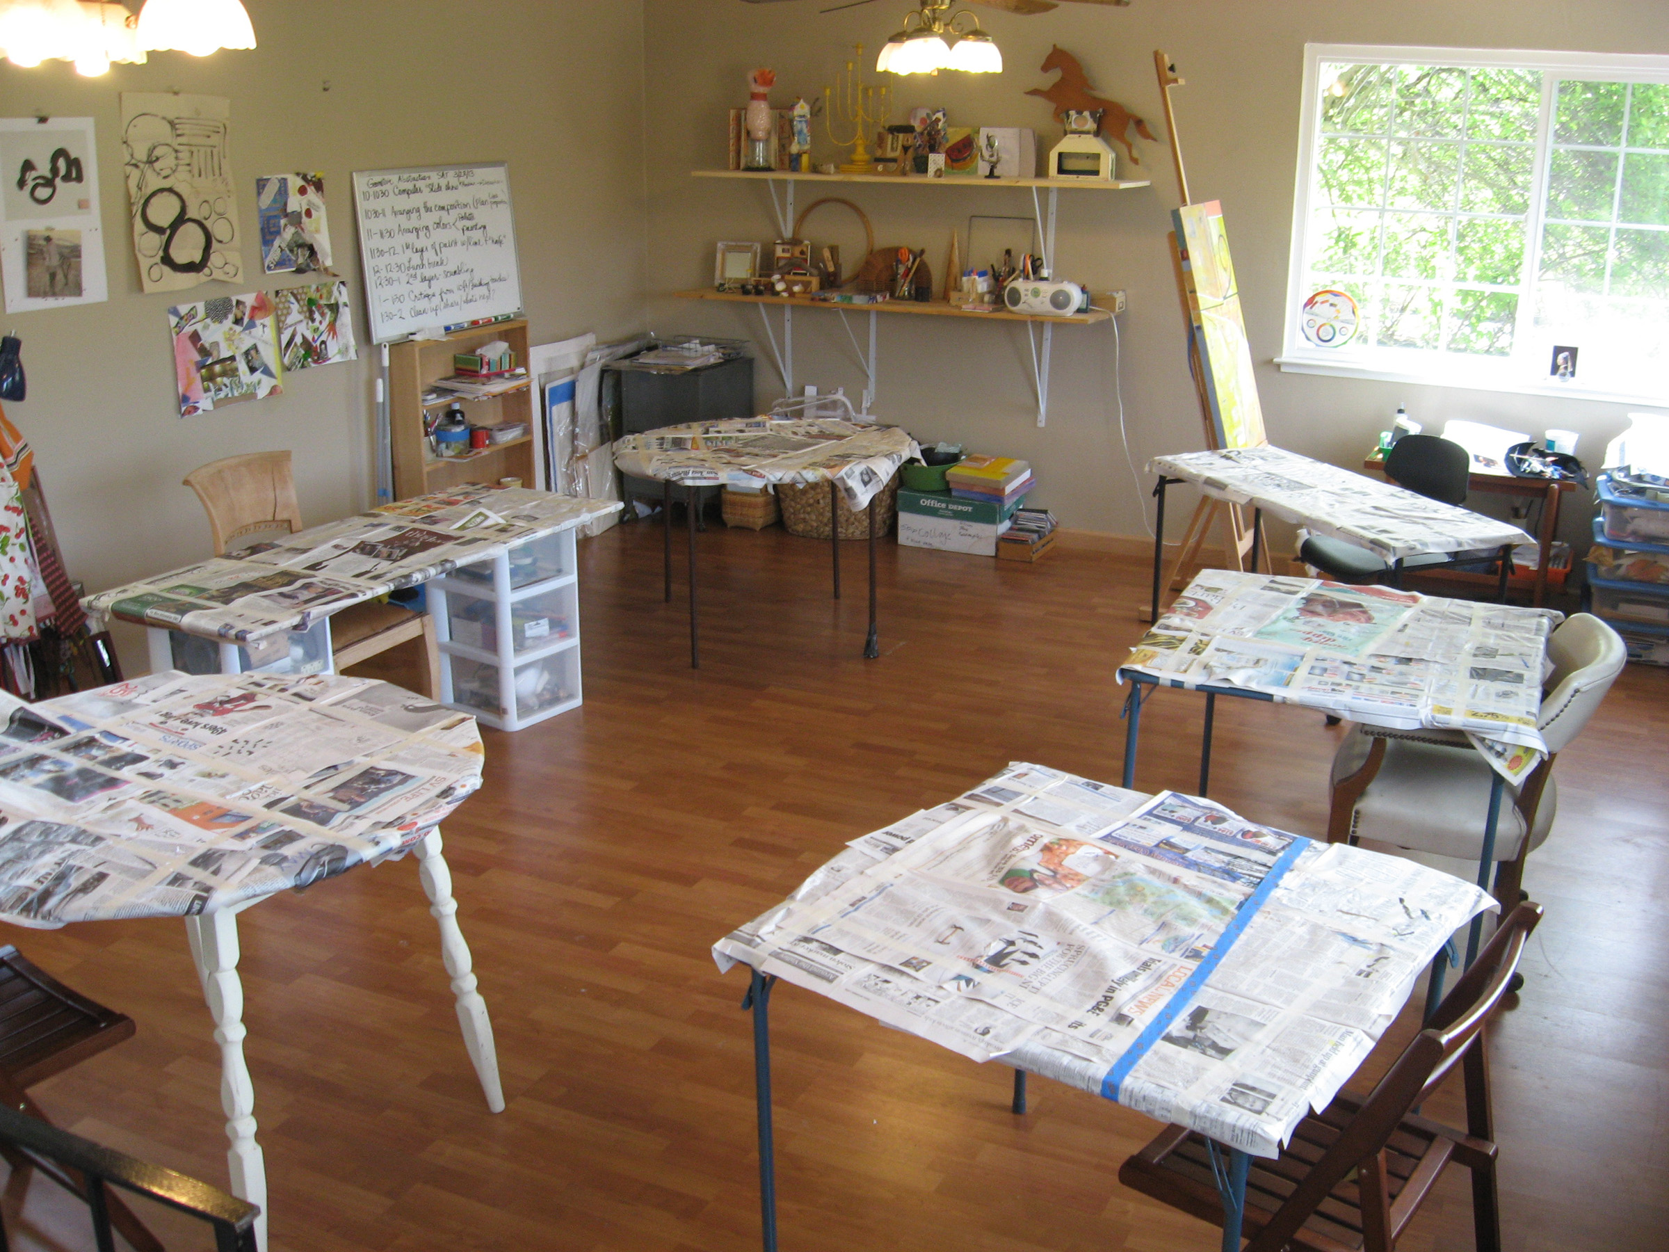

Open Project: Gouache, Ink, Watercolor, Acrylic, Collage, Sewing…etc.
Do you have half finished paintings you’d like to either wrap-up or start-on anew? Bring your own art in progress and get some things done. Enjoy helpful feed-back, ample supplies and the right ambience facilitate your creative flow. Do you just need a little time or direction to put that finishing touch on a cool project?
Monday-Thursday in June, 2, 3,4,5 2014, from10AM-2:00 PM
(30 minute break for brown bag lunch)
Fee: $30/session or $100 for all four (materials not included)

Call 408-649-6282 or email: zoya@artforpersonalgrowth.com
for more details. To look at Zoya’s art visit: www.Zoyart.com to view her teaching site go to: www.Artforpersonalgrowth.com

